ESIM Order Placement Refactored Menu Operation Manual (User Version)

My esIM Orders
Menu Description: A page for channels to place eSIM product orders, batch orders, terminations, and view order and card information.
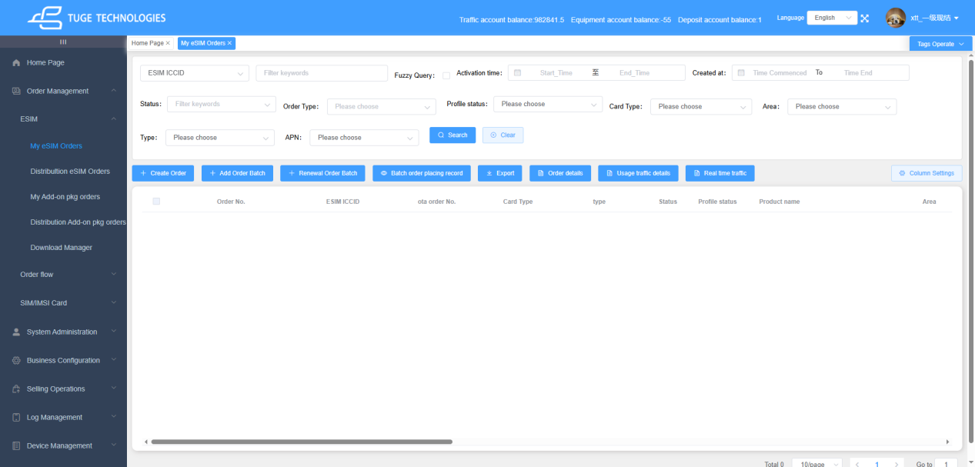

1.1 Description of Supported Query Conditions

1.1.1 Overview of the Filter Area
At the top of the page is a unified filter area that contains five modules: an exact-search dropdown, a fuzzy keyword input box, time-range filters, fixed dropdown filters, and function buttons. Multiple conditions can be combined to precisely filter eSIM card data, and all filter conditions support cumulative effect.

1.1.2 Exact Search Dropdown in the Upper Left (Core Query Item)
1) Function Description
The first input box is an exact query component with a switchable search dimension. Select the search field from the dropdown on the left, enter the corresponding value in the input box on the right, and perform an exact match query. The default selected search item is: ESIM ICCID.
2) List of Search Dimensions Available in the Dropdown
Click the dropdown arrow to switch to the following search fields. After switching, the input box matches only the data of the selected field:
- ESIM ICCID: unique eSIM chip number (default option)
- Order No.: primary business order number
- OTA Order No.: third-party order number entered when the channel places an order
- Data Order No.: data order number
- Product Name: exact search by package/product name
- IMEI2: bound device identifier
- Carrier Description: exact match for carrier remark or name
3) Steps
- Click the dropdown arrow on the left side of the input box and select the field to search.
- Enter the full corresponding value in the input box (exact match; supports query by a single card number/order number).
- After combining with other filter conditions, click the [Search] button to execute the query.

1.1.3 Fuzzy Query Keyword Input Box
To the right of the exact search box is a general fuzzy query input box used together with the exact search box (IMEI2 and Carrier Description do not support fuzzy queries).
- It takes effect after selecting the "Fuzzy Query" checkbox.
- Enter any text, and the system performs a fuzzy contains match across multiple fields in the entire table.
- If the checkbox is not selected, this input box does not participate in the query logic.

1.1.4 Time Range Filter Module (Two Independent Time Filters)
1. Activation Time Filter
- Purpose: filter data by the order activation time range
- Operation: click the "Start Time" and "End Time" input boxes respectively. The selection is accurate to the day, and activation time for the current day or later cannot be selected.
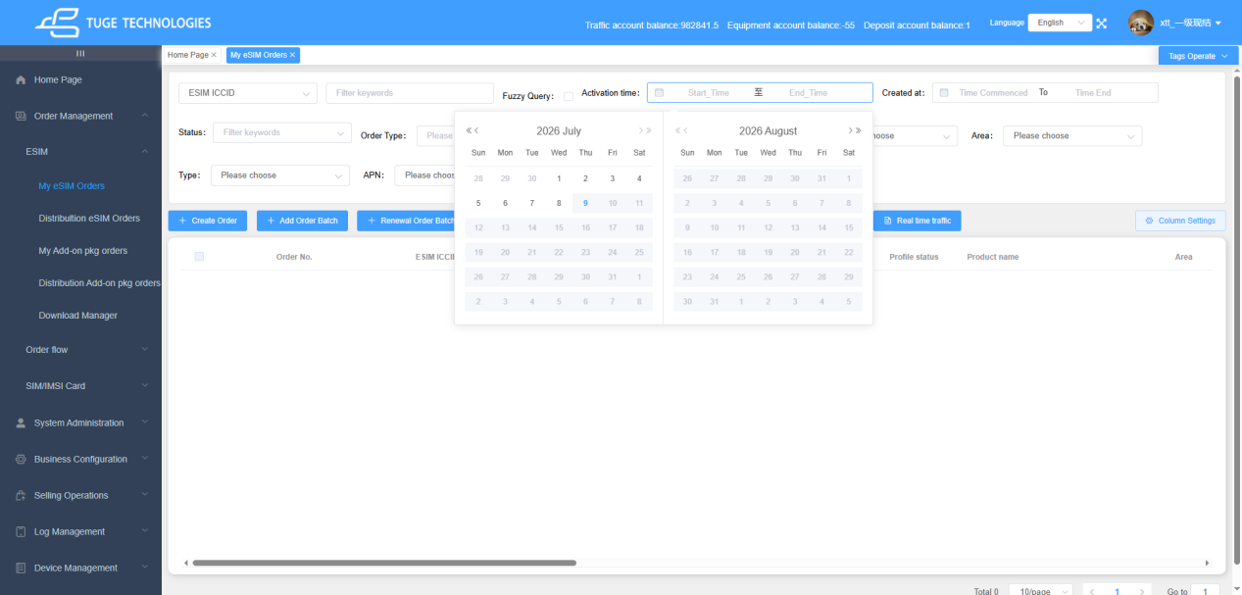
2. Creation Time Filter
- Purpose: filter data by the order creation time
- The logic is exactly the same as that of the activation time filter, and the two time conditions can be used together.

1.1.5 Fixed Dropdown Filter Conditions (Single-Select Dropdown)
The second and third rows are fixed-dimension dropdown filters. Click a dropdown to select an option. If no option is selected, that condition is not limited:
- Status: filter by card business lifecycle status
- Order Type: distinguishes order categories such as retail / batch / rental
- Profile Status: eSIM profile statuses such as activated / expired / downloaded
- Card Type: carrier card. The dropdown shows only the set of card types from the channel's existing orders.
- Region: where the purchased package is valid. The dropdown shows only the set of covered regions included in the channel's existing orders.
- Type: order placement method
- APN: access point network configuration. Consistent with card type and region, and shows only the set of APN information from packages in the channel's existing orders.

1.2 Description of Supported Page Buttons

1.2.1 Search Buttons
[Search]: used together with the query conditions in 1.1. After selecting query conditions, click to perform a query.
[Clear]: used together with the query conditions in 1.1. Click to restore all query conditions to their initial default values.

1.2.2 Function Buttons

[Create Order]
entry for placing a single order. After opening it, you only need to select a product and fill in an email address (optional) to place the order.
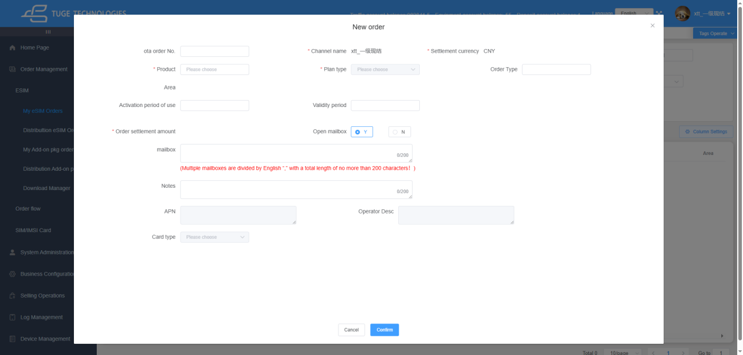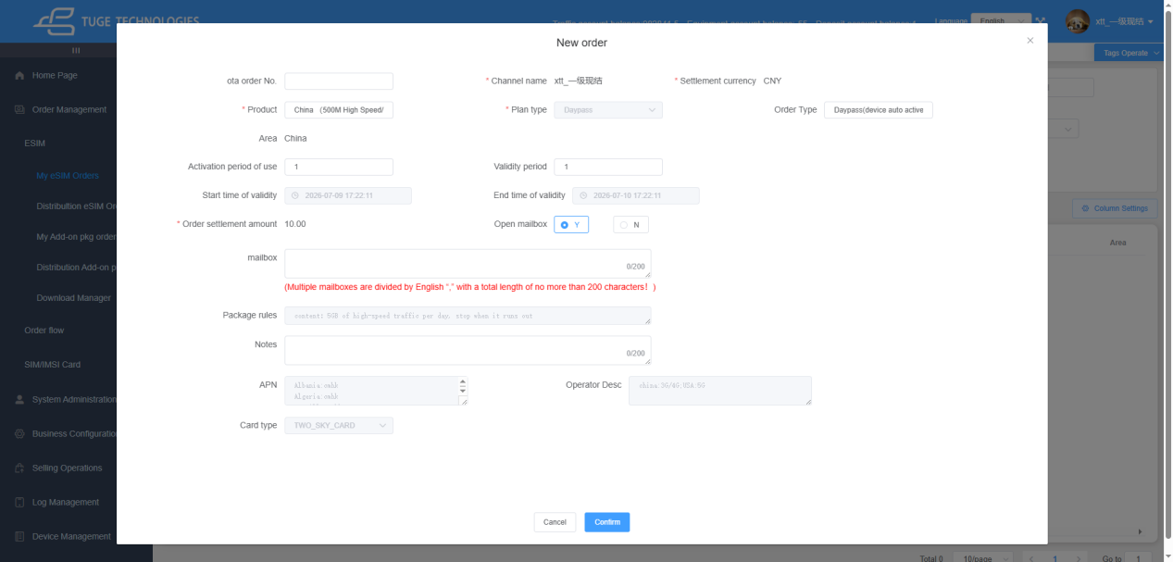

[Add Order Batch]
Order Placement Instructions
After a channel agent submits an order, the order will enter an asynchronous retry queue for queuing. When the order is scheduled and formal retries start, the system activates a 30-minute automatic retry mechanism, during which manual order cancellation is unavailable. If the order ultimately fails, automatic full refund and order cancellation will be executed without manual operation required.
entry for batch ordering. A channel can place multiple orders at one time. The default is 1 order, and up to 500 orders are supported at the same time(Order placement can normally be completed within one minute). The operation is the same as Place Order ,select a product and then modify the required order quantity.
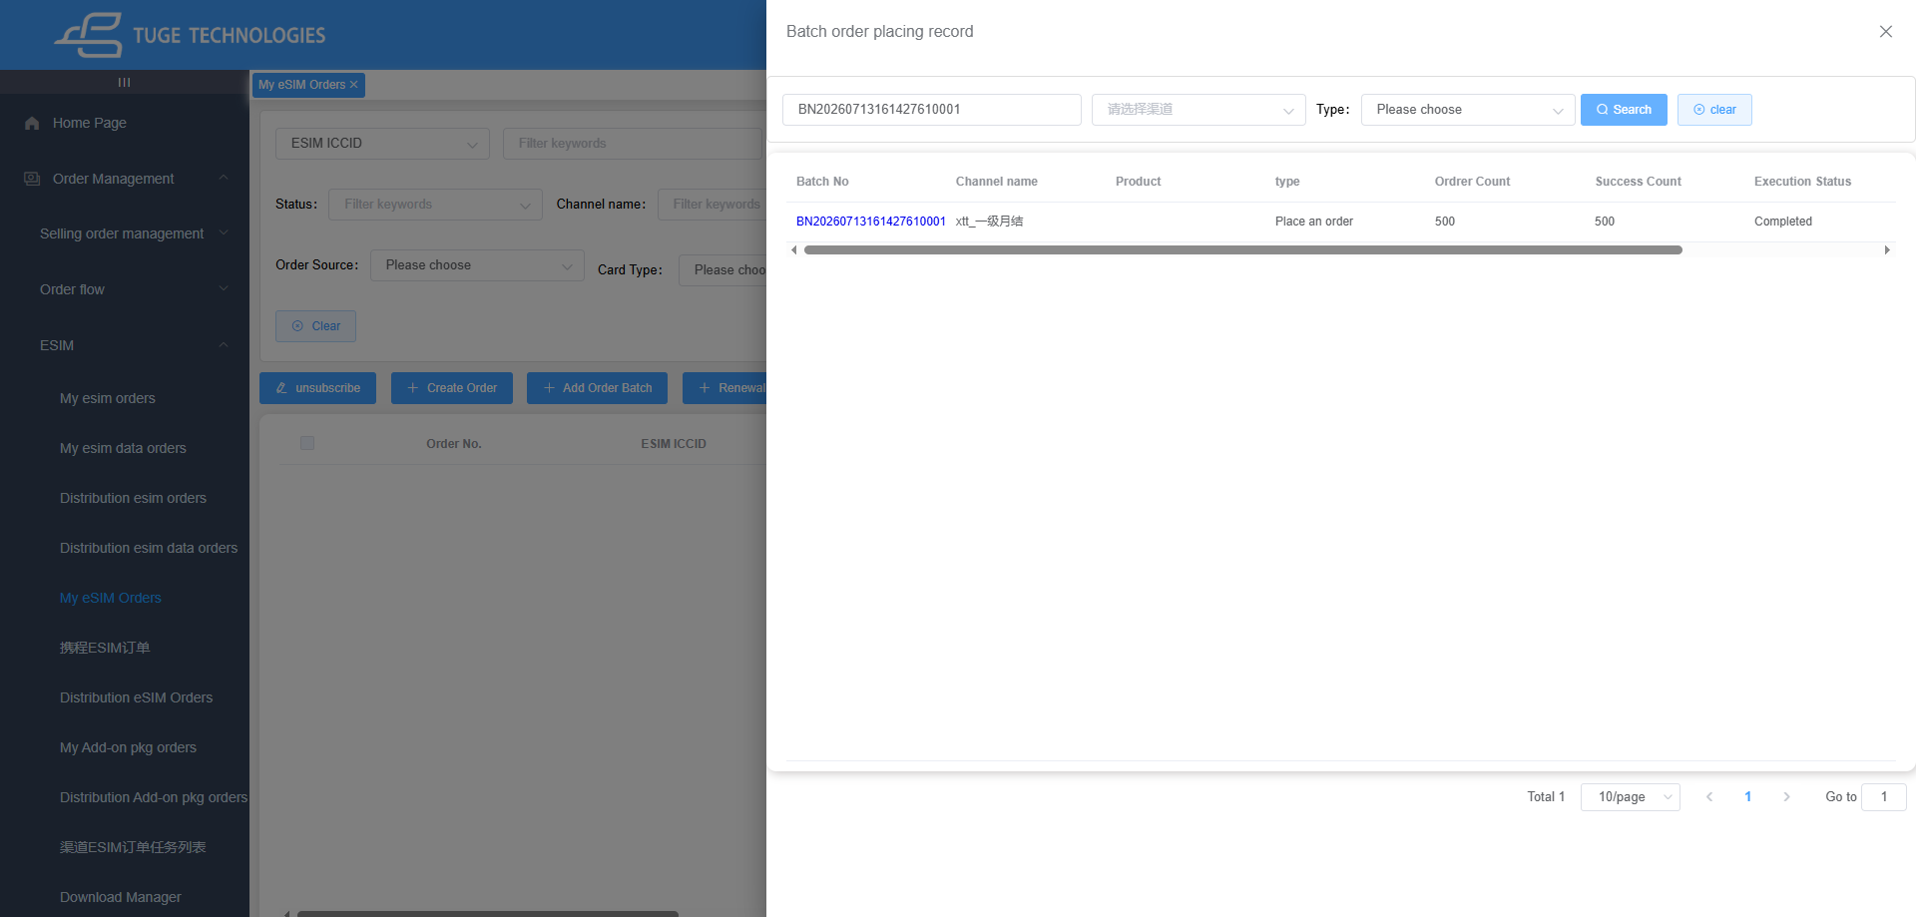
After bulk order placement, a pop-up window for Bulk Order Records will pop up and perform reverse query based on the batch number of this order submission. Once all orders are placed successfully, the execution result will be updated to Completed.
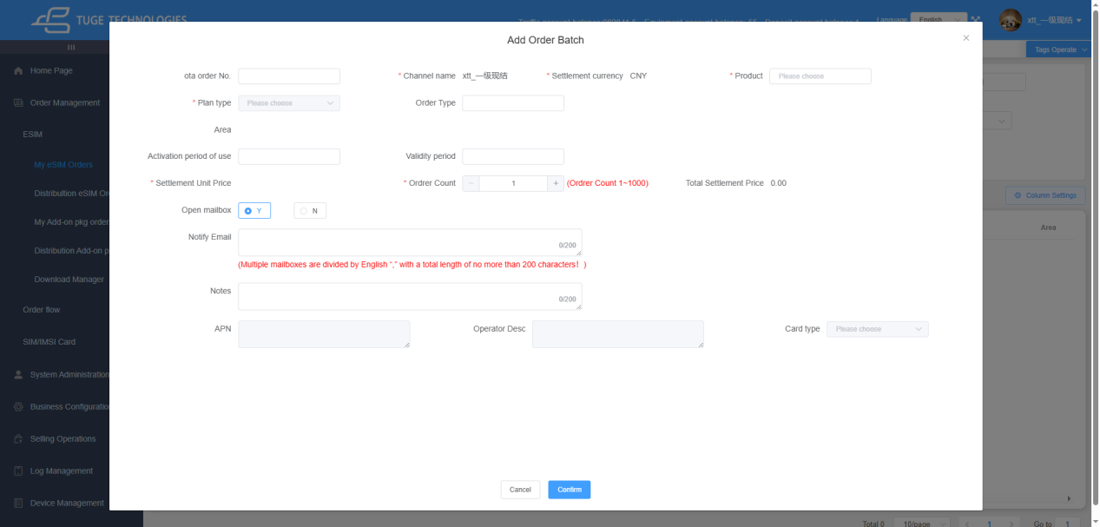

[Renewal Order Batch]
for cards that have already been ordered and support renewal:
1) enter the ICCID on the renewal page to perform a renewal
2) Multiple cards can be renewed at the same time, with a maximum of 100 orders per batch.
3) When renewing multiple cards at the same time, all cards must belong to the same card type.
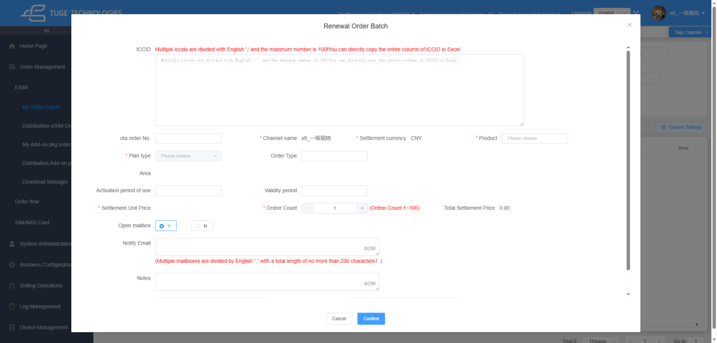

[Batch order placing record]
view historical batch order records, including all historical batch orders and their details
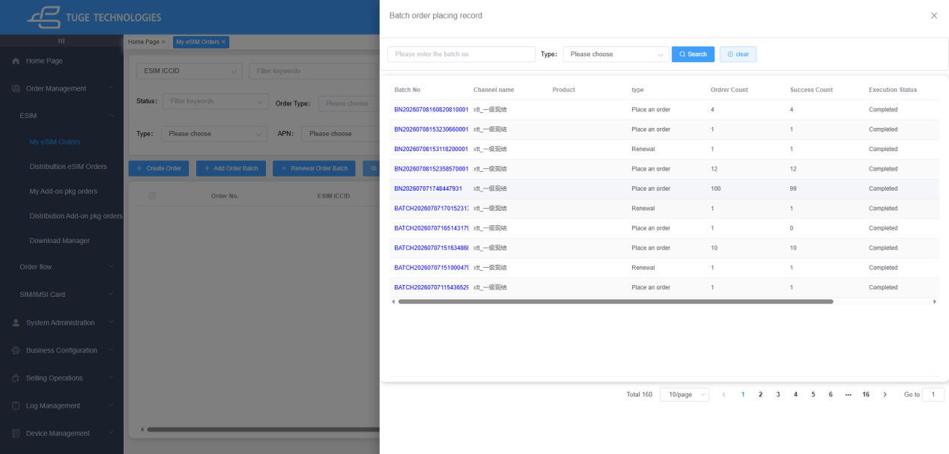
Click a batch number to view the success/failure status of all orders in that batch, or directly export the order details of that batch.
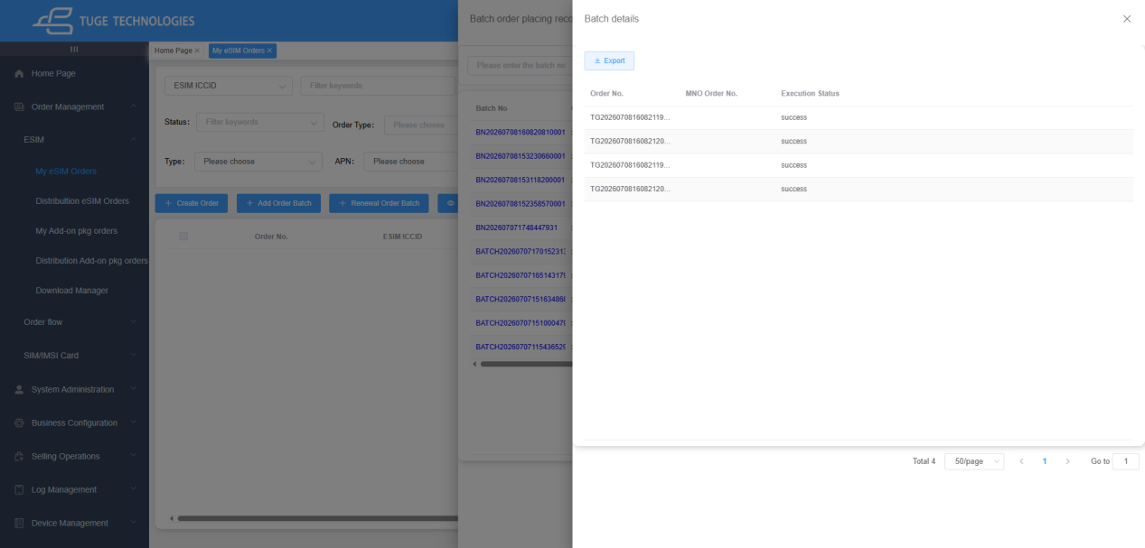

[Terminate Package]
for orders that are In Use or Used Up and are allowed to be terminated. After an order is selected, the [Terminate Package] button is displayed. Click it to end the current package immediately. After successful termination, the order status changes to Terminated. For cards with renewal orders, the renewed package starts being used directly after toggling mobile data or turning airplane mode on/off.
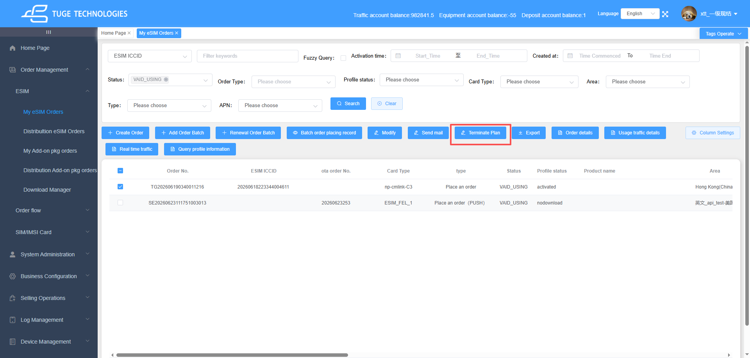
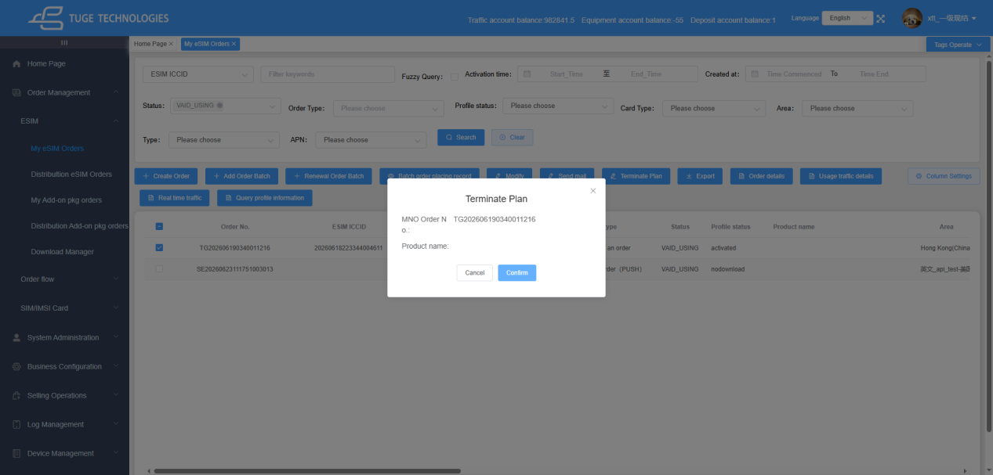

[Purchase Top-Up Package]
currently supported only for C4 daily package products. There are same-day top-up packages and daily top-up packages.
A same-day top-up package takes effect on the day it is ordered. The effective start time is the same day as the daily package order, with the same hour, minute, and second as the order creation time. The effective end time is the effective start time + 24h.
A daily top-up package calculates the remaining cycle days of the current package and places top-up packages for the corresponding number of days. After ordering, one top-up package order takes effect each day within the remaining package cycle.
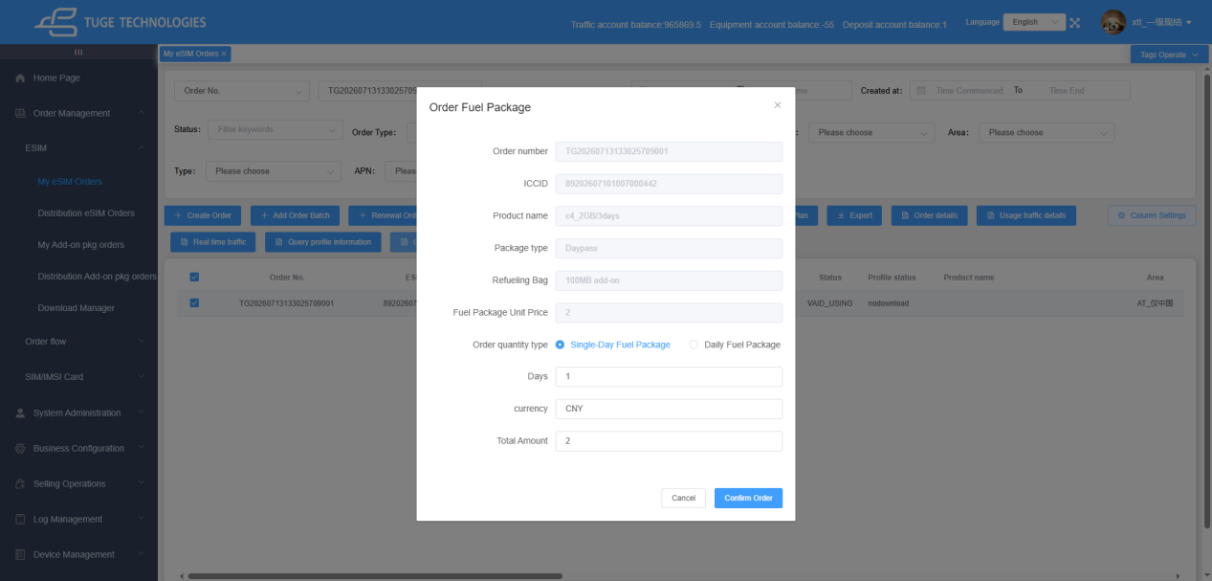

[Top-Up Package Orders]
view the details of top-up package orders already purchased for the current order
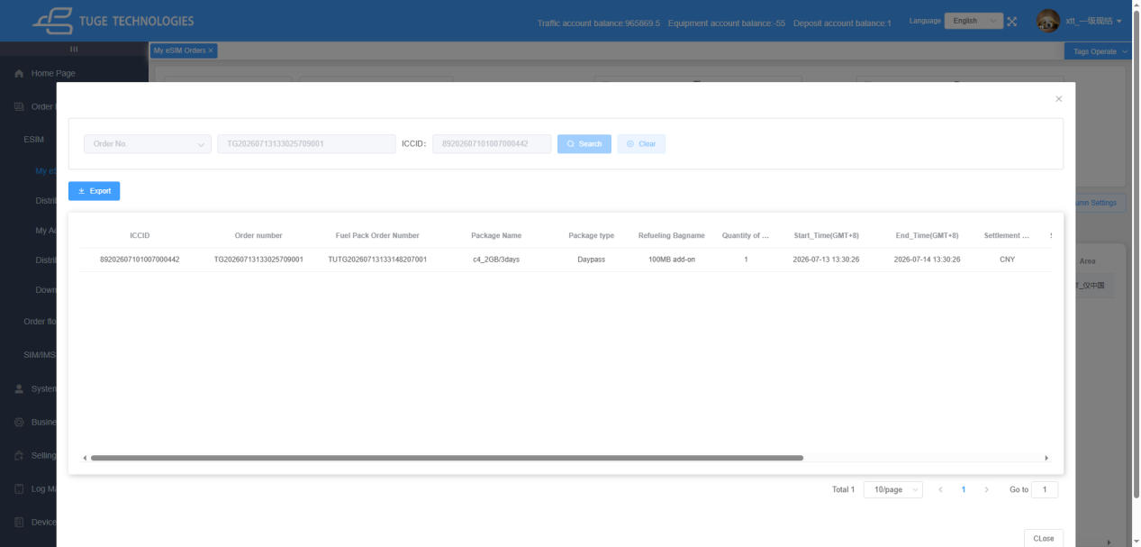

[Send mail]
except for voided orders, this button can be used to resend an email to the customer. If an email address was provided when the order was placed, it is auto-filled (and can be modified). If no email address was provided, it can also be entered manually before sending.
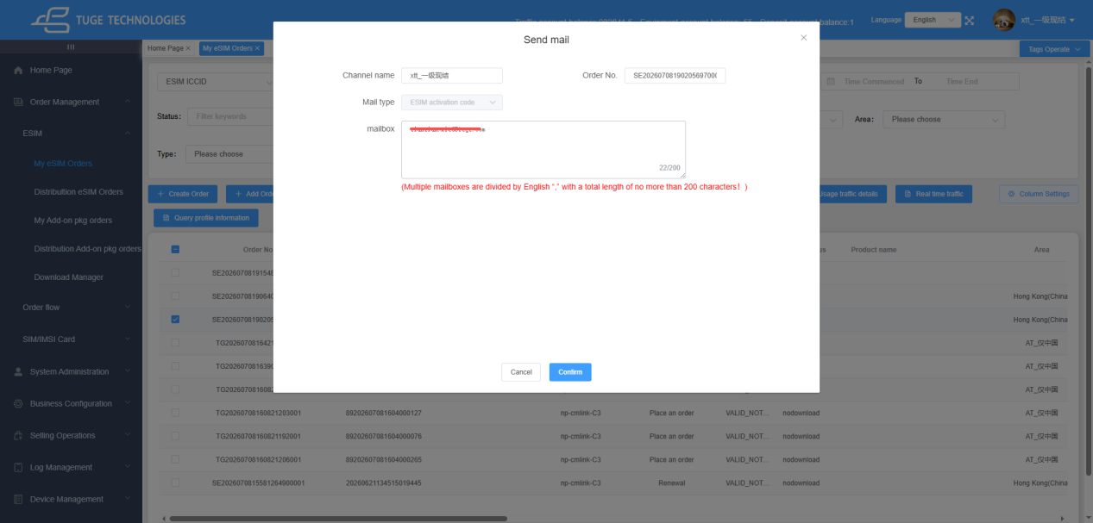

[Export]
click to export all current orders for the channel. After export, a prompt dialog is displayed. Click the redirect option and you will be taken to the "Download Management" page to query this export record.
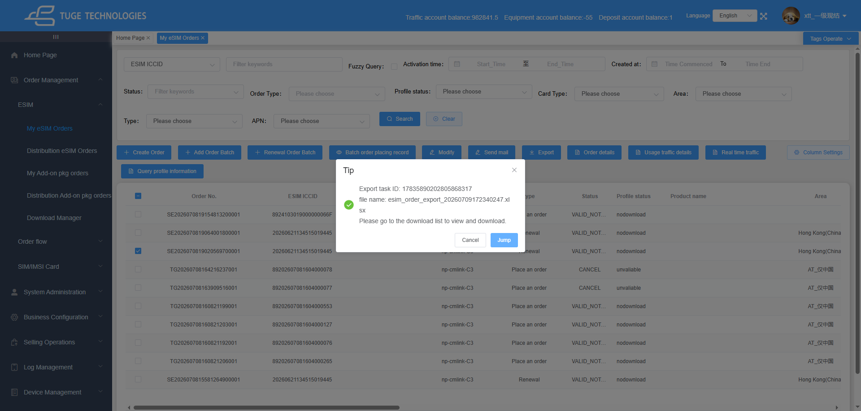

[Order details]
viewing includes Data Order Information and Order Details. Data Order Information displays the main information of the card and package, while Order Details displays information such as the package name and order price.
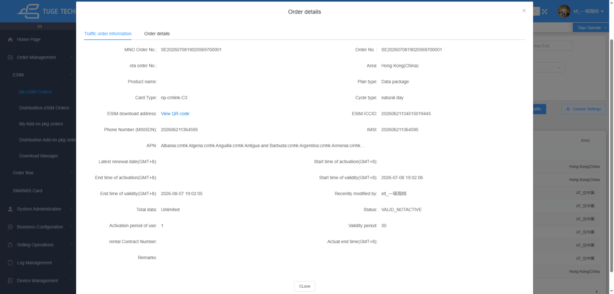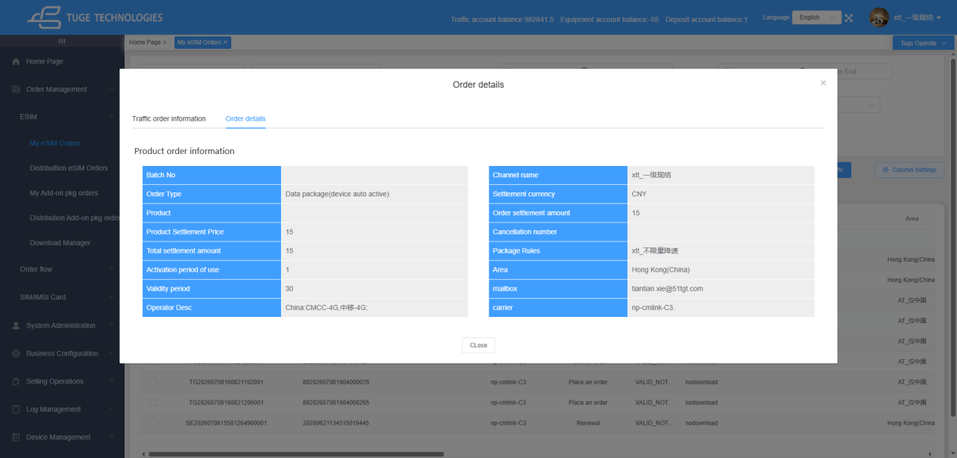

[Usage traffic details]
for orders that have already been activated and used, this page allows you to view data usage statistics. By default, it queries detailed usage records for the past week. You can use the time filters at the top to select a different time range. (Note: Data Usage Details does not display real-time usage.)
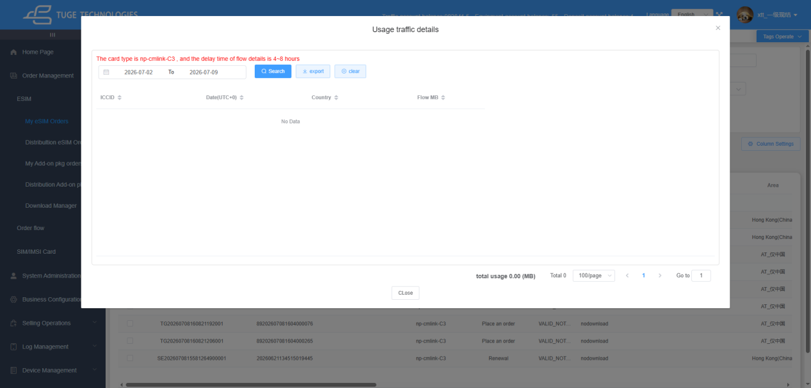

[Real Time Traffic]
queries the cumulative total data usage of the order from activation to the moment of query. Voided orders and expired orders older than 90 days cannot query real-time data usage.
Real-Time Data Usage View for Daily Packages:
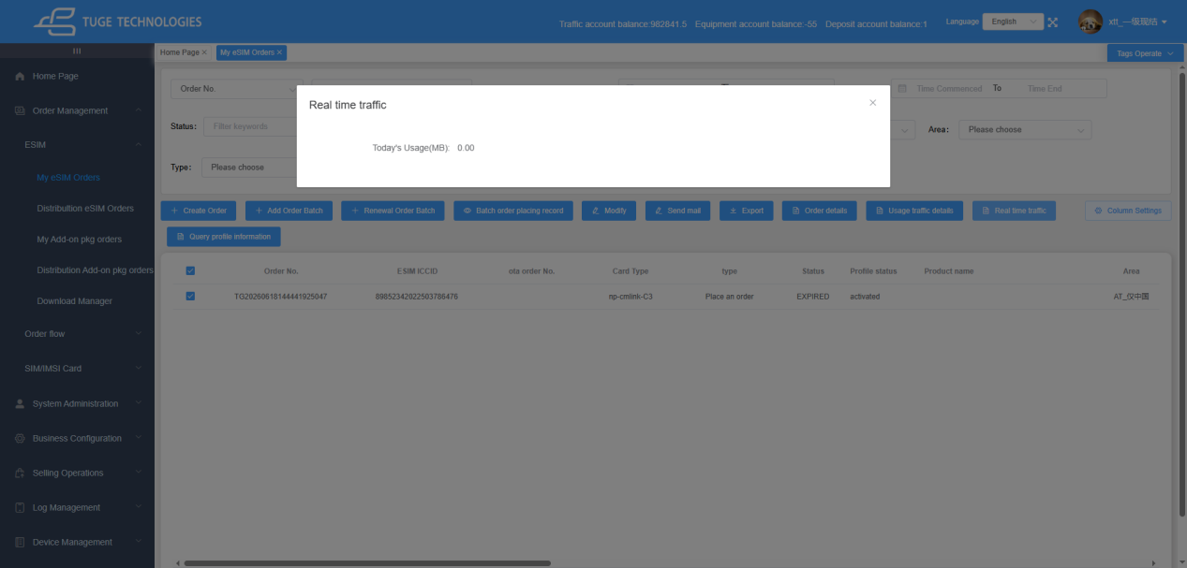
Real-Time Data Usage View for Data Packages:
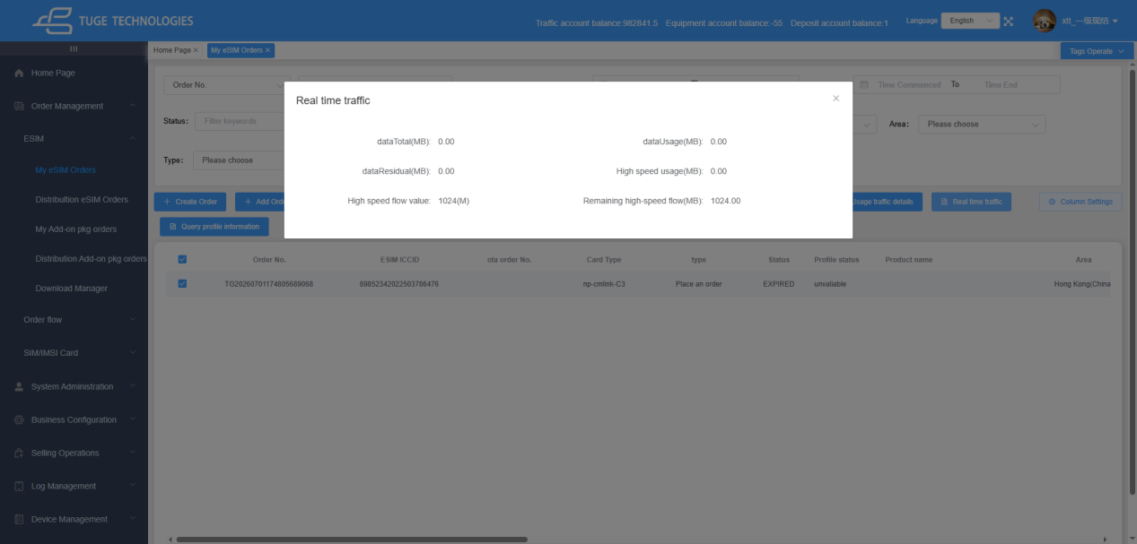

[Column Settings]
fixed in the upper-right corner of the order list. By default, all columns are selected. You can uncheck columns that are not needed or not of interest based on actual requirements. After unchecking, the corresponding columns are hidden from the page in real time. (The column settings configuration is stored in the browser cache. If the user does not actively clear the browser cache, the configuration continues to take effect after it is set. After clearing the cache, the previous state can be restored by configuring it again.)
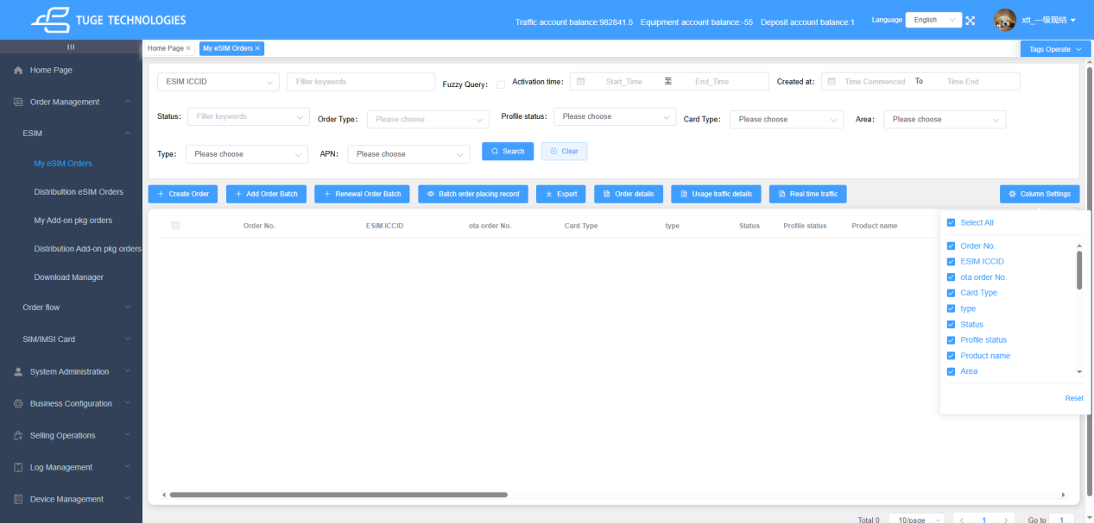

[Modify]
only order remarks can be modified
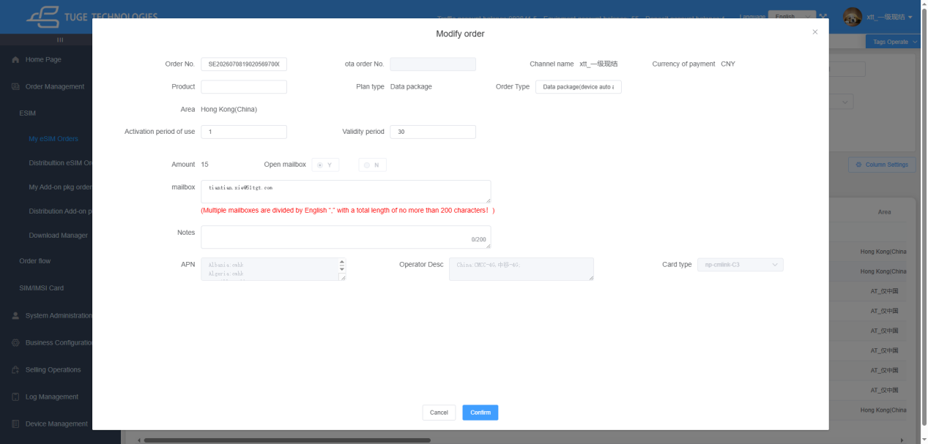

【Query profile information】
Display Order Profile Information
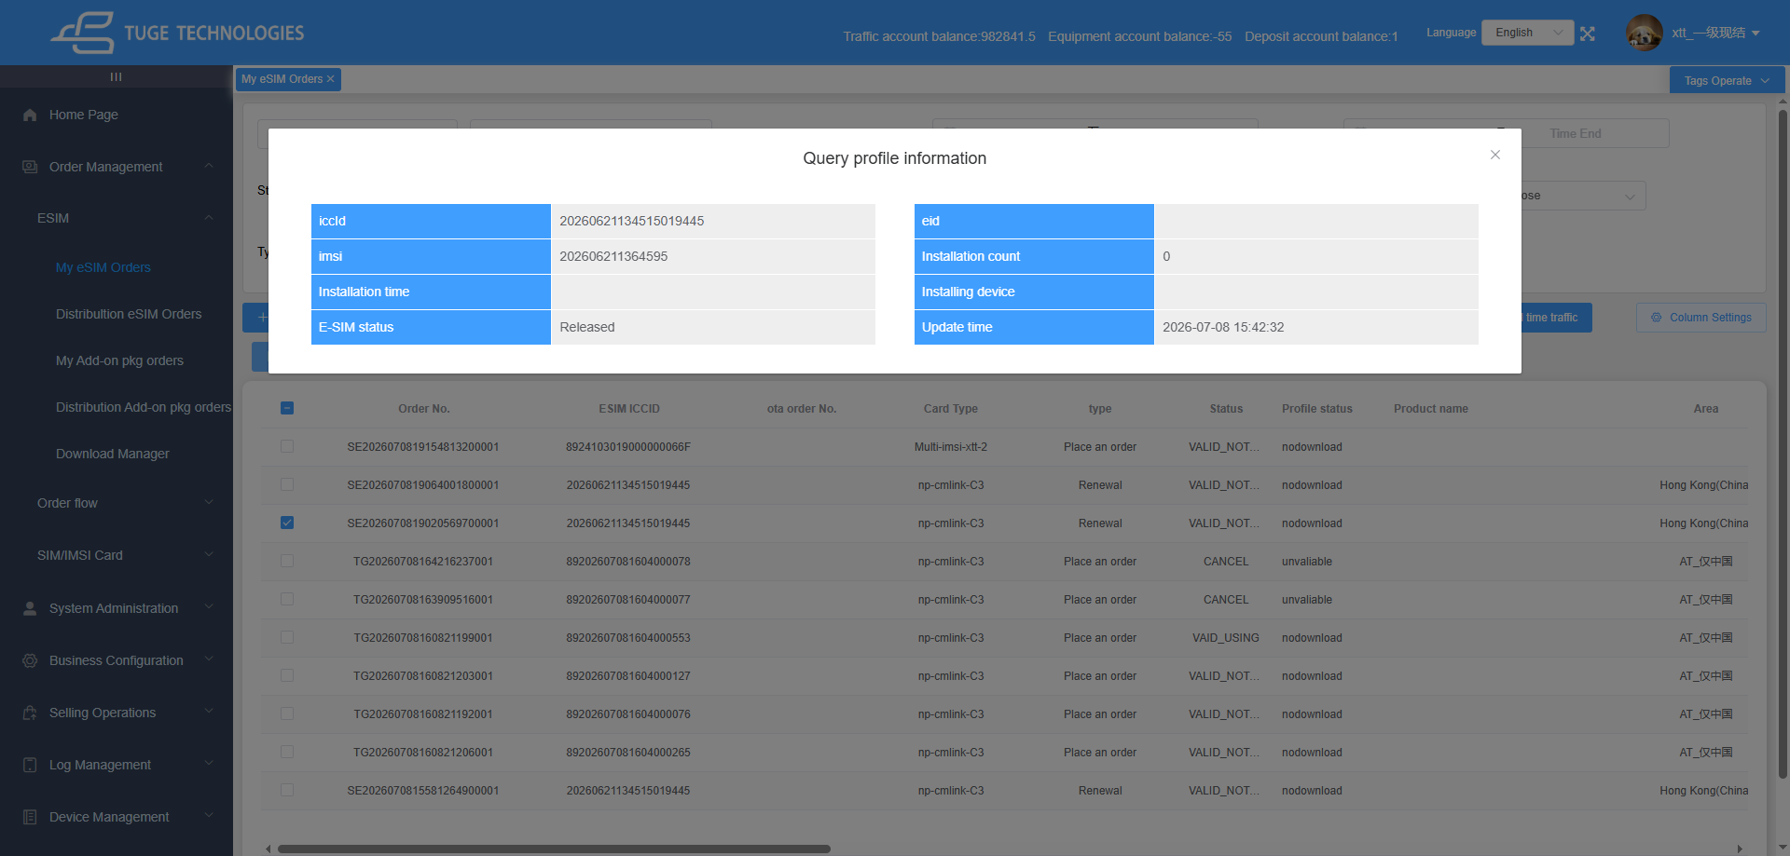

1.2.3 eSIM Order Status Description (Matching the system enumeration values in the screenshot)
PAID
If card resource shortage or service exceptions cause order placement failures, the order will switch to PAID. The system retries submission every 2 minutes for up to 15 attempts. If placement still fails after all retries, the order is automatically cancelled and marked as CANCEL. If card resources are successfully allocated during retries, the order proceeds to subsequent workflows. Manual order cancellation is unavailable during the retry period.
UNPAID
If the superior channel adopts cash settlement and its account balance cannot cover the order cost, distributor orders will enter the Unpaid state upon submission. The system retries payment every 2 minutes for a maximum of 15 times. If the superior channel tops up sufficient balance during retries, the order proceeds normally. If the balance remains insufficient after all retries, the order will be marked as CANCEL, and the pre-paid amount will be automatically refunded. Manual order cancellation is unavailable during the retry period.

VALID_NOTACTIVE
After a card resource is allocated to the order but the card has not been activated for use.
VALID_ACTIVATED
Temporary status for time-specified activation products. The order remains VALID_ACTIVATED until the scheduled activation time arrives. It will switch to VAID_USING once the user activates the card and starts consuming data traffic.
VAID_USING
The order enters this status after receiving an activation notification or CDR record.
EXHAUST
All traffic allowance of the data package has been consumed; this status only applies to data-only plans.
TERMINATION
Status after successfully executing the package termination function on orders in VAID_USING or EXHAUST status.
CANCEL
Orders under PAID or Unpaid status that fail to obtain card resources after all retries will be automatically cancelled and set to CANCEL.
EXPIRED
The order switches to EXPIRED if the user fails to activate the card within the valid activation window, or if the activated data usage period ends.

1.2.4 Description of Page Column Fields
Column Name | Field Description
Order No. | The globally unique business order number on the platform. It is generated automatically when the order is created and uniquely identifies a single order placement record as the primary key.
ESIM ICCID | The unique identifier of the eSIM chip. Each eSIM card has an independent code used for device profile download and carrier identification.
OTA Order No. | Third-party order number entered on a third-party platform
Card Type | Classification of eSIM module models, used to distinguish cards from different vendors
Type | Classification of order business operations, used to distinguish order placement scenarios
Status | Overall business lifecycle status of the eSIM card, controlling whether the card can be used normally
Profile Status | Download/generation status of the eSIM profile, representing the progress of carrier profile delivery
Product Name | Name of the purchased data package product
Area | Country/region coverage where the package is valid
ESIM Download address | Entry for downloading the eSIM profile. Click "View QR Code" to display the download QR code for loading the profile by scanning with a mobile phone.
Latest Activation Time (GMT+X) | The deadline by which the card can be activated after creation. After this time, the card expires automatically and cannot be activated. The time zone is the local time zone of the channel user.
Start Time of activation(GMT+X) | The start time when the data package officially takes effect after the user scans and activates the card. Blank if not activated.
End Time of activation(GMT+X) | The expiration time of the package data. Data service is stopped when this time is reached. Blank if not activated.
Order Source | Identifier of the channel through which the order was created, distinguishing online batch orders from online single-card orders
Available Days | Valid usage duration purchased for the package, in days
Total Data | Total data quota included in the package; displayed only for data packages
Validity Period | Buffer days from order creation until the latest activation deadline
Order Type | Detailed package business type, used to distinguish rules such as automatic activation / specified activation
mailbox | Contact email address reserved by the customer placing the order, used to receive card credentials, bills, and activation notifications
Settlement Currency | Currency type used for settlement with the channel agent
Total Settlement Amount | Amount payable by the channel for settlement for this order
Retail Currency | Currency type charged to end customers for package sales (retail field)
Total Retail Amount | Actual amount paid by the end customer for purchasing the package (retail field)
Created By | Name of the back-office account that created the order
Creation at(GMT+X) | Time when the order was generated and stored, displayed in the time zone of the channel location
Recently modified at(GMT+X) | Time of the last update to the order information. If no changes were made, it is the same as the creation time.

Distribultion eSIM Orders
Menu Description: supports channels in placing orders, renewals, terminations, and order viewing for their own distribution channels. The permissions are the same as the Channel eSIM Orders page. (Renewals cannot cross levels; each channel can renew only for its directly subordinate channels.)
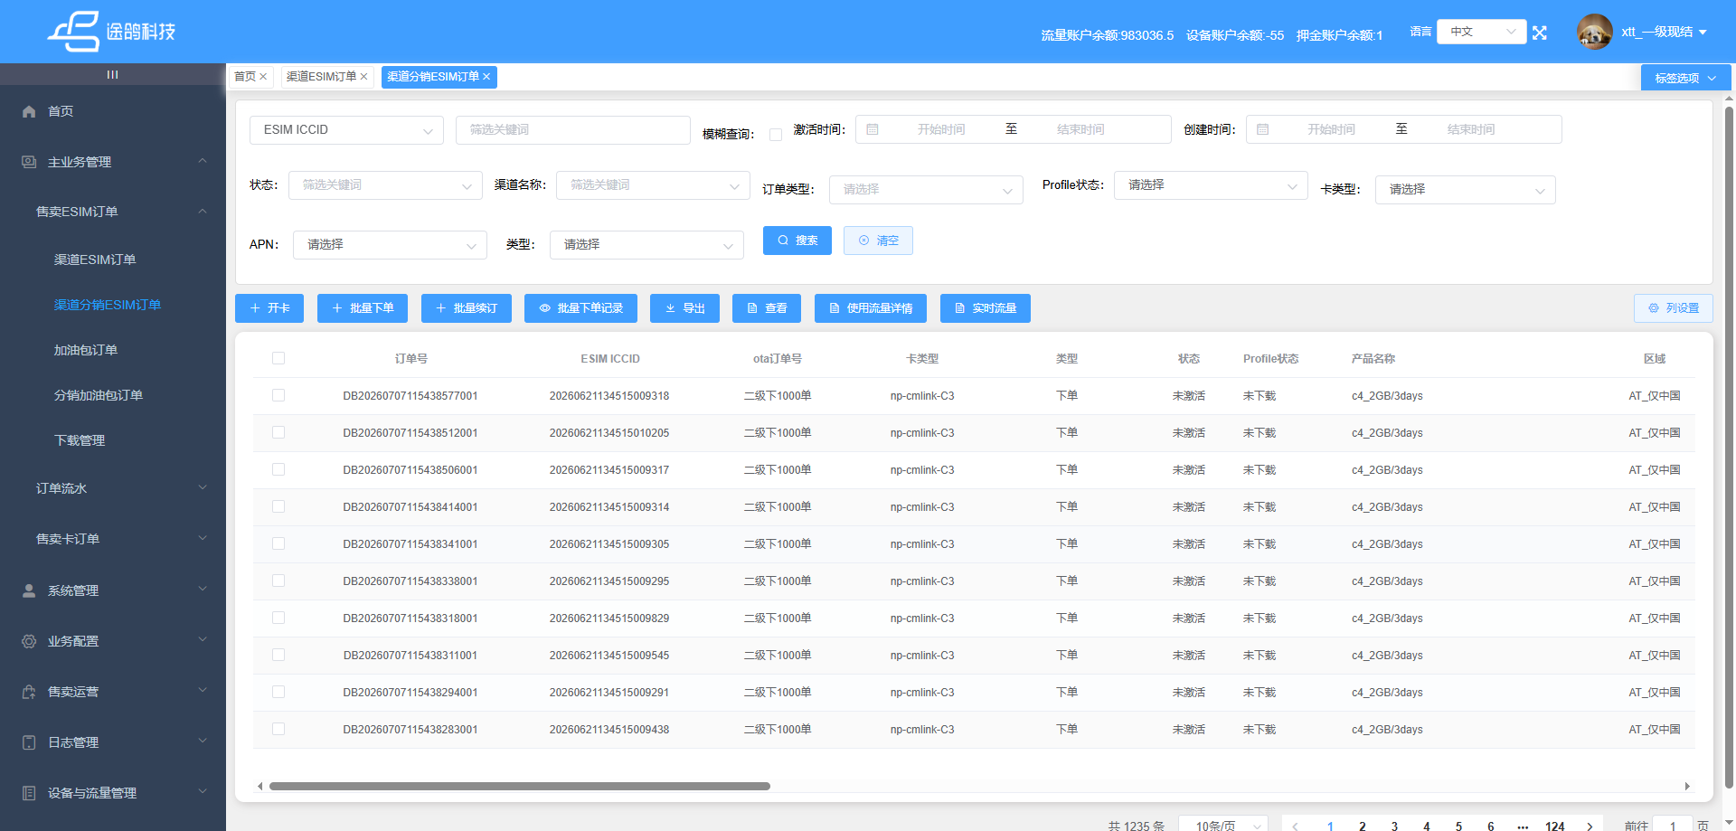
The page queries, buttons, and displayed columns are the same as those on the Channel eSIM Orders page in the previous section and are not repeated here. The list only adds one extra column, "Commission". Commission formula: Commission = distribution channel package selling price - first-level channel package selling price
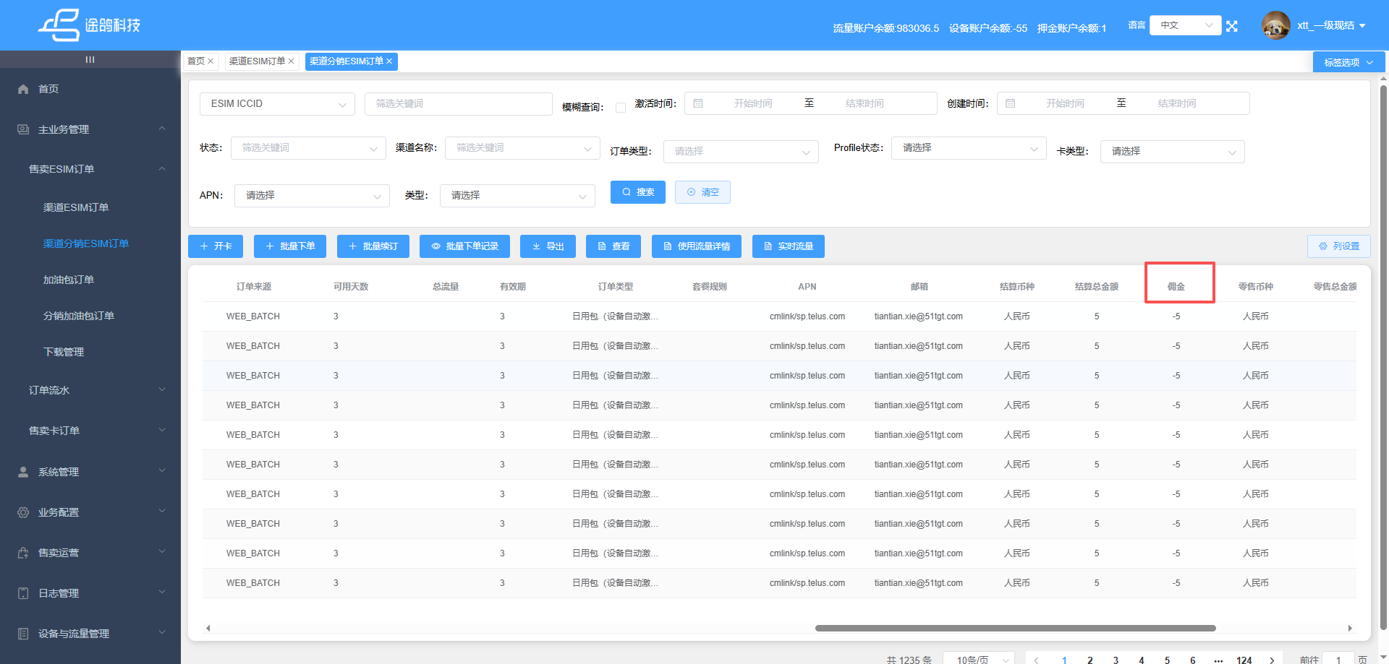

Download Manager
Menu Description: when a channel user exports order data or details of batch orders, the export records are written to the Download Management page. Users can view historical export records or download exported file attachments on this page
